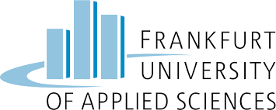

Cloud Computing

*Summer 2024 (Milestone-2)*

# 

# Group Members

* Muhammad Fazeel Razzaq (1504349)
* Hunain Sajid (1450976)
* Md Fakhrul Islam (1476031)
* Md Abul Mokarrom (1523447)
* Uzair Abid Lakhiar (1511635)

# 

# 

**Group Members** **1**

**Detailed migration roadmap, cloud architecture, and DevOps/Cloud Native application with detailed description! Decide on an appropriate migration strategy for each application!** **5**

Overview 5

GCP Strategy Implementation 5

Simplicity and Manageability 5

Resource Grouping: 5

VPC Network as Perimeter: 5

Architecture Components 6

Platform as a Service (PaaS) - VPC 1 6

Infrastructure as a Service (IaaS) - VPC 2 6

Software as a Service (SaaS): 7

On-Premise: 8

Networking and Security 8

Hub-and-Spoke Architecture: 8

Cloud Interconnect 9

VPN Gateway 9

DevOps: Utilizing Docker, CI/CD, and Terraform for DevOps and Infrastructure as Code (IaC) 10

Docker Containers 10

CI/CD Pipelines: 10

Terraform for IaC: 10

**Migration Strategy** **11**

Phase 1: Understand Your Current State (1 month) 11

Assessment 11

Phase 2: Data Modeling and Architecture (1 month) 11

Data Modeling 11

Architecture Design: 11

Phase 3: Security and Compliance (1 month) 11

Security Design: 11

Compliance: 12

Phase 4: Prepare for Migration (2 months) 12

VPC and Network Setup 12

Infrastructure Setup 12

Phase 5: Data Migration (4 months) 12

Finance Department SAP Suite 12

Finance Department's Legacy Application 12

HR Software, Shift Management Software, Office Suite for HR 13

Reporting and Shift Management for Production 13

Warehouse Management and Deliforce: 13

CRM (Sales, Operations, Customer Service), Lead Management: 13

Business Analytics, Tableau: 13

Quality Management, Supply Management, Facility Management: 14

Legislation Management, Information Management, Office Suite: 14

Webshop: 14

Phase 6: Validate the Migration (2 months) 14

Testing 14

User Acceptance Testing (UAT) 14

Optimization 15

Phase 7: Transitioning Systems (1 month) 15

Go-Live Preparation: 15

Go-Live Execution: 15

Post-Migration Support: 15

Phase 8: Monitoring and Optimization (Ongoing) 15

Continuous Monitoring: 15

Performance Tuning: 15

Security Audits: 15

User Training and Documentation: 16

**Public, Private, and Hybrid Cloud Infrastructure Strategy** **16**

Public Cloud Strategy 16

Application 16

Service Models 16

Benefits 16

Private Cloud Strategy 16

Applications 16

Service Models 17

Benefits 17

Hybrid Cloud Strategy 17

Applications 17

Service Models 17

Benefits 17

**Calculation of the cost of operation:** **18**

1. GKE Kubernetes for Webshop (Public VPC) 18

GKE Nodes: 18

Cloud Load Balancer for GKE: 18

Monthly Cost Calculation: 18

2. HR Department Applications on App Engine (VPC 1) 19

App Engine Instances: 19

3. Production Department Tools on App Engine (VPC 1) 19

App Engine Instances: 19

Storage Calculation for VPC-1 20

Network Costs (VPC 1) 20

Network Egress: 20

HR Department Applications on App Engine (VPC 1) 20

Network Egress: 20

Production Department Tools on App Engine (VPC 1) 21

Network Egress: 21

**4. IaaS (VPC 2)** **21**

VM Instances: 21

Storage Costs For VPC-2 22

Network Egress 22

**Cloud Interconnect** **23**

Calculation: 23

**VPN Gateway** **23**

Calculation: 24

Security tool: 24

**Critical Analysis** **25**

Benefits 25

1. Scalability and Flexibility 25

2. Enhanced Security 25

3. Operational Efficiency 25

4. Cost Management 25

Drawbacks 26

1. Complexity in Management 26

2. Learning Curve for New Tools 26

3. Dependence on CSP: 26

**Your assessment of the cloud transformation and your advice on the future direction of the project!** **26**

Cloud Transformation Solution 26

Cloud Platform Selection 26

Infrastructure Design 27

Networking 27

Storage Solutions 27

Database Solutions 27

High Availability and Redundancy 27

Security Measures 27

Monitoring and Logging 28

Disaster Recovery 28

Future Direction Recommendations 28

Continuous Integration and Continuous Deployment (CI/CD) 28

Microservices Architecture 28

DevOps Practices 28

Cloud Cost Management 28

Ongoing Training and Development 29

**References** **30**

# 

# Detailed migration roadmap, cloud architecture, and DevOps/Cloud Native application with detailed description! Decide on an appropriate migration strategy for each application!

## Overview

The cloud architecture for the organization on Google Cloud Platform (GCP) is structured to ensure secure, scalable, and efficient operations across multiple Virtual Private Clouds (VPCs). This architecture adheres to best practices recommended by GCP documentation, facilitating streamlined management and enhanced security.

## GCP Strategy Implementation

Following the guidance from GCP documentation, we have implemented a VPC strategy that aligns with the following principles:

### Simplicity and Manageability

Opting for multiple VPCs tailored to specific departmental needs ensures that each VPC can be managed independently, allowing for simpler maintenance and troubleshooting.

### Resource Grouping:

Each VPC groups resources with common requirements and characteristics, such as applications and services used by different departments, into separate VPC networks. This approach enhances operational clarity and efficiency[1].

### VPC Network as Perimeter:

By establishing each VPC network border as the perimeter for potential issues, the organization effectively isolates and secures resources within their respective VPCs, minimizing the impact of any security incidents or operational challenges[1].

## Architecture Components

### Platform as a Service (PaaS) - VPC 1

GKE Kubernetes for Webshop: Hosting the webshop application for customer-facing services.

Cloud Load Balancer for GKE: Manages traffic distribution across GKE instances for scalability and availability.

HR Department: Hosts HR management systems and tools.

HR Software and Shift Management Software on App Engines: Specific applications for HR operations and employee shift scheduling.

Production Department:

Reporting Management: Tools for generating and analyzing production reports.

Shift Management: Software to manage employee shifts and schedules.

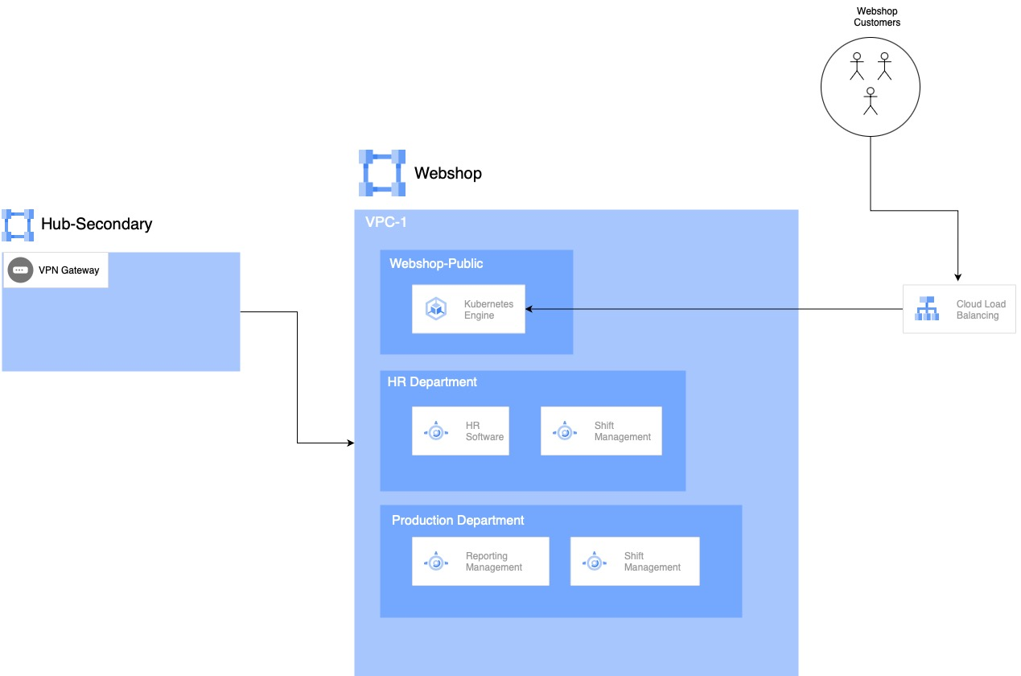

*Figure: Vpc-1*

### Infrastructure as a Service (IaaS) - VPC 2

CRM for Operations, Sales, and Customer Support: Hosted on IaaS to manage customer relationships and streamline sales and support operations.

Business Analytics - Tableau for Sales: Utilized for data visualization and analytics specifically tailored for sales activities.

Supply Management: Handles procurement and inventory management processes.

QM Software: Quality Management software ensuring compliance and quality control.

Facility Management: Manages physical facilities and assets.

Warehouse Department's Management - Deliforce: Logistics and workforce management for warehouse operations.

IT Department Build and Testing: Infrastructure for development, testing, and deployment of IT solutions.

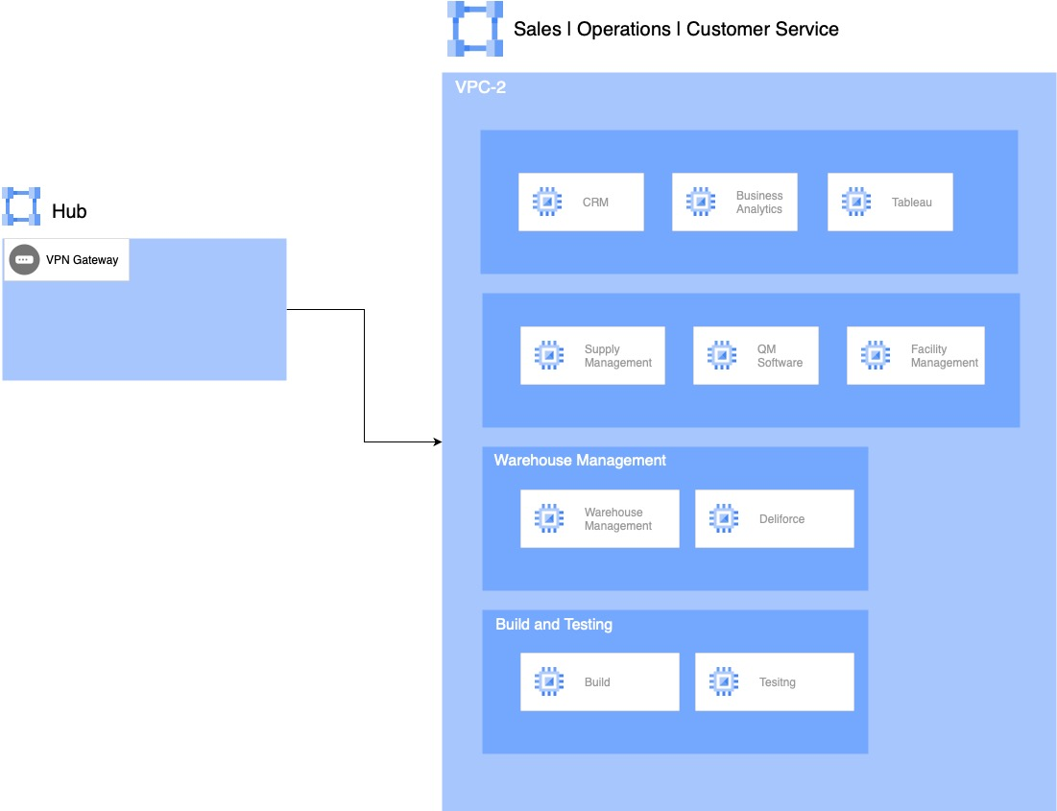

*Figure: VPC-2*

### Software as a Service (SaaS):

G-Suite: Office suite used across all departments for productivity and collaboration.

Jira Service Desk Integration: Integrated with G-Suite for efficient IT service management.

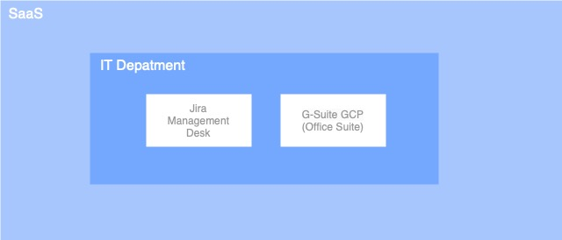

*Figure: SaaS*

### On-Premise:

Finance Department:

Hosts legacy applications and SAP systems.

Utilizes BaaS (G-Suite) for office suite needs.

Sales Legacy Lead Management: On-premise solution for managing sales leads.

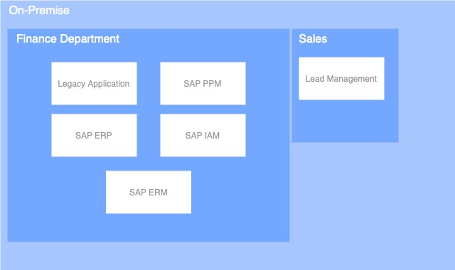

*Figure: On-Premise*

### Networking and Security

#### Hub-and-Spoke Architecture:

Two VPCs (VPC 1 and VPC 2) are interconnected in a hub-and-spoke model for centralized management and efficient communication.

#### Cloud Interconnect

In our Google Cloud Platform (GCP) architecture, Cloud Interconnect plays a vital role by connecting our on-premise infrastructure securely to the cloud. This integration ensures reliable access for our Finance department to cloud resources. Cloud Interconnect is seamlessly integrated into our hub-and-spoke architecture, serving as a critical component within our hub VPCs. It facilitates robust communication and data transfer between our on-premise network and the various departmental applications hosted in spoke VPCs. This setup strengthens our infrastructure's resilience and scalability, supporting our hybrid cloud environment effectively.

#### VPN Gateway

The VPN Gateway in our hub VPCs securely connects employees to applications across our Google Cloud Platform (GCP) environment. It establishes encrypted tunnels for authorized users, ensuring private and authenticated access to critical business applications. This integration supports seamless connectivity for remote and on-site employees, maintaining high-security standards while facilitating efficient access to resources within each VPC. The VPN Gateway's role in our hub-and-spoke architecture strengthens network reliability and adherence to strict security protocols, enhancing overall operational efficiency in our cloud infrastructure on GCP.

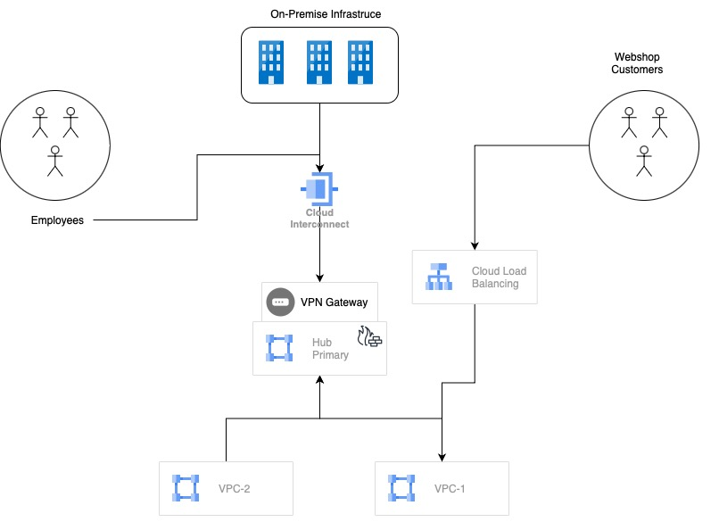

*Figure: Overall Architecture*

## 

### DevOps: Utilizing Docker, CI/CD, and Terraform for DevOps and Infrastructure as Code (IaC)

#### Docker Containers

**Purpose:** Packaging applications into portable, consistent environments.

**Benefits:** Ensures application consistency, isolation, and efficient resource usage.

#### CI/CD Pipelines:

**Continuous Integration (CI):** Automates code integration and testing.

**Continuous Deployment (CD):** Automated deployment after successful CI, ensuring reliable and efficient updates.

#### Terraform for IaC:

**Purpose:** Declaratively define and manage infrastructure configurations.

**Benefits:** Automates provisioning and updates across environments, improves consistency and scalability.

# Migration Strategy

## Phase 1: Understand Your Current State (1 month)

### Assessment

* + Conduct a comprehensive inventory of current systems, applications, and dependencies.
  + Identify data, storage, and compute requirements.
  + Evaluate network requirements and compliance standards.
  + Document current architecture and workflows.
  + SolarWinds to map dependencies between applications and infrastructure components.

## Phase 2: Data Modeling and Architecture (1 month)

### Data Modeling

* + Analyze data structures, relationships, and usage patterns.
  + Develop a data model that aligns with GCP’s architecture.
  + Plan data partitioning, sharding, and indexing strategies.
  + Create detailed ERDs using Lucidchart and establish data governance policies following DAMA-DMBOK guidelines.

### Architecture Design:

* + Define the VPC structure tailored to departmental needs.
  + Public VPC: Design for the webshop application.
  + Private VPCs: Design for management, CRM, HR, production, and warehouse applications.
  + Plan for high availability, disaster recovery, and scalability.

## Phase 3: Security and Compliance (1 month)

### Security Design:

* + Define security groups, firewall rules, and IAM roles.
  + Plan VPN Gateway and Cloud Interconnect setup for secure connectivity.
  + Implement Zero Trust architecture using Okta and ensure all data is encrypted using GCP Cloud KMS.

### Compliance:

* + Follow GDPR guidelines and use CloudGuard Dome9 for continuous compliance monitoring.

## Phase 4: Prepare for Migration (2 months)

### VPC and Network Setup

* + Create VPCs as per the architecture.
  + Implement VPN Gateway and Cloud Interconnect.
  + Configure hub-and-spoke architecture.

### Infrastructure Setup

* + Use Terraform to provision infrastructure and set up CI/CD pipelines using GitLab CI.
  + Set up Docker environments.
  + Apply security policies, firewall rules, and IAM configurations.

## Phase 5: Data Migration (4 months)

### Finance Department SAP Suite

* + **Strategy**: On Premise System.
  + **Steps**:
    - Install on the on-premise servers.

### Finance Department's Legacy Application

* + **Strategy**: Maintain on-premises for 3 years.
  + **Steps**:
    - The backup servers are removed, and current on-premises infrastructure of servers is maintained.
    - Maintain legacy application on-premises with a secure VPN connection to GCP, planning a phased migration over three years.

### HR Software, Shift Management Software, Office Suite for HR

* + **Strategy**: PaaS on Private VPC.
  + **Steps**:
    - Implement blue-green deployment for HR software migration and validate data integrity using automated scripts.
    - Deploy using GKE within the private VPC.
    - Migrate data.
    - Conduct integration tests.

### Reporting and Shift Management for Production

* + **Strategy**: PaaS on Private VPC.
  + **Steps**:
    - Deploy using GKE within the private VPC.
    - Migrate existing data and configurations.

### Warehouse Management and Deliforce:

* + **Strategy**: IaaS on Private VPC for Warehouse Management and Deliforce.
  + **Steps**:
    - Deploy Warehouse Management on GKE within the private VPC.
    - Integrate Deliforce with Iaas setup.
    - Migrate data and conduct tests.

### CRM (Sales, Operations, Customer Service), Lead Management:

* + **Strategy**: IaaS on Private VPC.
  + **Steps**:
    - Deploy CRM using IaaS model within the private VPC.
    - Integrate Lead Management.
    - Conduct user training and validate deployment.

### Business Analytics, Tableau:

* + **Strategy**: IaaS on Private VPC.
  + **Steps**:
    - Deploy business analytics tools.
    - Migrate data.
    - Perform integration and validation tests.
    - Use BigQuery for data warehousing and Tableau for data visualization.

### Quality Management, Supply Management, Facility Management:

* + **Strategy**: IaaS on Private VPC.
  + **Steps**:
    - Deploy on VMs within the private VPC.
    - Configure integration with other systems.
    - Conduct tests.

### Legislation Management, Information Management, Office Suite:

* + **Strategy**: SaaS on on-premise Server.
  + **Steps**:
    - Deploy on VMs within the private VPC.
    - Migrate data.
    - Perform validation tests.

### Webshop:

* + **Strategy**: PaaS on Public VPC.
  + **Steps**:
    - Deploy using App Engine.
    - Set up Google Cloud Load Balancer.
    - Perform testing and launch.

## Phase 6: Validate the Migration (2 months)

### Testing

* + Conduct thorough testing for each migrated application.
  + Validate integrations and performance.
  + Implement automated testing using Selenium and conduct UAT with key users.

### User Acceptance Testing (UAT)

* + Engage end-users for acceptance testing.
  + Collect feedback and address any issues.
  + Conduct beta testing for CRM and create a feedback loop for user suggestions.

### Optimization

* + Monitor performance and optimize resources.
  + Implement auto-scaling and load balancing.
  + Use GCP’s Cost Management tools for resource optimization and tune performance regularly.

## Phase 7: Transitioning Systems (1 month)

### Go-Live Preparation:

* + Finalize all configurations and ensure readiness.
  + Prepare a detailed cutover plan.

### Go-Live Execution:

* + Switch to live operations for all migrated applications.
  + Monitor the transition and resolve any issues.

### Post-Migration Support:

* + Provide ongoing support and maintenance.
  + Plan for continuous improvement and updates.
  + Assign a dedicated support team and keep detailed documentation available for post-migration support.

## Phase 8: Monitoring and Optimization (Ongoing)

### Continuous Monitoring:

* + Implement monitoring using Grafana and set up alerts for key performance indicators.

### Performance Tuning:

* + Regularly analyze performance data.
  + Optimize resources and configurations based on usage patterns.

### Security Audits:

* + Conduct security audits quarterly using Nessus and ensure timely patch management.
  + Update security measures as needed.

### User Training and Documentation:

* + Conduct regular training sessions for IT staff and end-users, and keep documentation updated on Confluence.

# Public, Private, and Hybrid Cloud Infrastructure Strategy

## Public Cloud Strategy

### Application

* Webshop (hosted on GKE with Cloud Load Balancer)

### Service Models

* **PaaS**: Leverage Google Kubernetes Engine (GKE) for scalability and managed services.

### Benefits

* Scalability and flexibility
* Reduced infrastructure management
* High availability and disaster recovery

## Private Cloud Strategy

### Applications

* HR Software, Shift Management Software, Office Suite for HR
* Reporting and Shift Management for Production
* Warehouse Management, Deliforce
* CRM (Operations, Sales, Customer Service), Lead Management
* Business Analytics (Tableau), Office Suite, Quality Management, Supply Management, Facility Management, Legislation Management, Information Management.

### Service Models

* **IaaS**: For applications requiring specific configurations (e.g., Quality Management, Supply Management, Facility Management, Warehouse Management, Deliforce, CRM, Business Analytics, Tableau, Facility Management).
* **PaaS**: For internally developed applications (e.g., HR Software, Shift Management, Reporting Management,).
* **SaaS**: For business applications (e.g. Legislation Management, Information Management).

### Benefits

* Enhanced security and control
* Customizable infrastructure
* Efficient management and operational clarity

## On Premise Cloud Strategy

### Applications

* Finance Department’s Legacy Application (initially on-premises) and SAP systems
* Lead management (Sales Department)

### Service Models

* **IaaS**: Used for on-premises legacy applications and SAP systems for the Finance Department.

### Benefits

* Balance between on-premises control and cloud scalability
* Flexibility to manage applications that require both local and cloud resources
* Ensure compliance and data sovereignty for sensitive financial data

# Calculation of the cost of operation:

## 1. GKE Kubernetes for Webshop (Public VPC)

### GKE Nodes:

· Instance Type: n1-standard-4 (4 vCPUs, 15 GB memory)

· Number of Instances: 3

· Hourly Cost per Instance: $0.2448

· Monthly Hours: 720(24 hours per day and 30 days per month)

Total Cost for GKE Nodes: *Cost=3×0.2448×720=$528.77*

#### Cloud Load Balancer for GKE:

Load Balancing includes:

· Traffic Management

· Instance Health Checking

#### Monthly Cost Calculation:

· Forwarding Rule Cost: $0.025 per hour

· Data Processing Cost: $0.008 per GB

· Total Hours per Month: 720

· Data Processed: 10 TB (10,000 GB)

Forwarding Rule Cost: *Cost=0.025×720=$18*

Data Processing Cost: *Cost=0.008×10,000=$80*

Total Load Balancer Cost: *$18+$80=$98*

**Total Monthly Cost for Public VPC:**

*GKE Nodes Cost=$528.77*

*Load Balancer Cost=$98*

Total: *$528.77+$98=$626.77*

## 2. HR Department Applications on App Engine (VPC 1)

### App Engine Instances:

· Instance Type: n1-standard-4

· Hourly Cost per Instance: $0.2448

· Monthly Hours: 220(10 hours per day and 22 days per month)

· Number of Instances: 2(HR and Shift Management)

Cost per Instance per Month: *Cost=0.2448×220=$53.86*

Total Cost for HR Department Applications: *Cost=2×53.86=$107.71*

## 3. Production Department Tools on App Engine (VPC 1)

### App Engine Instances:

· Instance Type: n1-standard-4

· Hourly Cost per Instance: $0.2448

· Monthly Hours: 220

· Number of Instances: 2 (Reporting Management and Shift Management)

Cost per Instance per Month: *Cost=0.2448×220=$53.86*

Total Cost for Production Department Tools: *Cost=2×53.86=$107.71*

## Storage Calculation for VPC-1

· Cost per GB per month: $0.04

One (1) TB of storage required for the webshop application:

Monthly Cost Calculation: 1000 x 0.04 = $40

· Each VM needs 500 GB of Standard Persistent Disk except HR (2 TB)

· Cost per GB per month: $0.04

Storage for 3 VMS = 500×3= 1500 GB

Storage for Application (HR) = 2 TB

Total Storage for Applications = 3500 GB

Total Storage Cost per month = 0.04x3500 = $140

Total Storage Cost per month = 40+140 = $180

## Network Costs (VPC 1)

### Network Egress:

· Assumed Data Transfer for Public VPC: 10 TB per month

· Cost per GB: $0.12

Total Network Egress Cost for Public VPC:

Cost=10,000×0.12=$1,200

## HR Department Applications on App Engine (VPC 1)

### Network Egress:

· Assumed Data Transfer for HR Department: 5 TB per month

· Cost per GB: $0.12

Total Network Egress Cost for HR Department Applications:

Cost=5,000×0.12=$600

## Production Department Tools on App Engine (VPC 1)

### Network Egress:

· Assumed Data Transfer for Production Department: 5 TB per month

· Cost per GB: $0.12

Total Network Egress Cost for Production Department Tools:

Cost=5,000×0.12=$600

# 4. IaaS (VPC 2)

## VM Instances:

· Instance Type: n1-standard-4

· Applications: CRM, Business Analytics, Tableau, Supply Management, QM Software, Facility Management, Warehouse, Deliforce.

· Number of Instances: 10 (including 2 instances for build and testing)

· Hourly Cost per Instance: $0.2448

· Monthly Hours:

o 8 Instances (220 hours each)

o 2 Instances (720 hours each)

Cost per Instance per Month (220 hours): *Cost=0.2448×220=$53.86*

Total Cost for 8 Instances (220 hours): *Cost=8×53.86=$430.85*

Cost per Instance per Month (720 hours): *Cost=0.2448×720=$176.26*

Total Cost for 2 Instances (720 hours): *Cost=2×176.26=$352.51*

Total Cost for VM Instances: *$430.85+$352.51=$783.36*

## Storage Costs For VPC-2

Each VM needs 500 GB of Standard Persistent Disk (Main Applications) except Warehouse (1 TB) and CRM (6TB) and 200GB for build and Testing VMS each (2 instances).

· Cost per GB per month: $0.04

Storage for Applications (Business Analytics, Tableau, Supply Management, QM Software, Facility Management, Deliforce) =500×6= 3TB

Storage for Applications (CRM) = 6TB

Storage for Applications (Warehouse) = 1TB

Total Storage for Applications (Main) = 10TB

Total Storage Cost per month (Main Applications) = 0.04x10,000 = $400

Cost per VM for Storage (Build and Testing) =200×0.04=8

Total Storage Cost per month (Build and Testing) = 8x2=16

Total Storage Cost per month = 400+16 = $416

## Network Egress

· Assumed Data Transfer for IaaS: 15 TB per month

· Cost per GB: $0.12

Total Network Egress Cost for IaaS:

Cost=15,000×0.12=$1,800

# Cloud Interconnect

Cloud Interconnect provides a dedicated connection between your on-premise network and Google Cloud. The cost depends on several factors:

1. Capacity: You choose between Dedicated Interconnect or Partner Interconnect, with varying capacities (e.g., 10 Gbps or 100 Gbps).

2. Data Transfer: Costs are incurred based on the amount of data transferred over the interconnect link.

Assuming

· Capacity: 10 Gbps Dedicated Interconnect.

· Data Transfer: 10 TB per month.

· Monthly Cost: This includes the fixed cost for the interconnect and the data transfer cost.

o Dedicated Interconnect (10 Gbps): $1,700 per month for the circuit rental fee.

o Data Transfer: $0.02 per GB for data transfer over the interconnect.

## Calculation:

· Circuit Fee: $1,700

· Data Transfer Cost: 10 TB (10,000 GB) $0.02/GB = $200

Total Cloud Interconnect Cost: $1,700 (Circuit Fee) + $200 (Data Transfer) = $1,900 per month

# VPN Gateway

VPN Gateway provides secure, encrypted connectivity for remote employees and site-to-site connections to Google Cloud.

* VPN Tunnels: Costs are based on the number of VPN tunnels established.
* Data Transfer: Costs are incurred based on the amount of data processed through the VPN.

Assuming

· VPN Tunnels: 2 VPN tunnels (for redundancy).

· Data Transfer: 5 TB per month.

· Monthly Cost:

o VPN Tunnels: No charge for the first 100 tunnels; additional costs apply for premium features or high availability configurations.

o Data Transfer: $0.05 per GB for data processed through VPN tunnels.

## Calculation:

· VPN Tunnels: Free (for standard setup, additional costs may apply for premium features).

· Data Transfer Cost: 5 TB (5,000 GB) $0.05/GB = $250

Total VPN Gateway Cost: $0 (for tunnels) + $250 (Data Transfer) = $250 per month

## Security tool:

Monthly cost for security tool Okta: $50

**Total Cost of Operation (Monthly)** = $626.77+$107.71+$107.71+$180+$1200+$600+$600+$783.36+$416+$1800+$1900+$250+$50 = $8,621.55

**Total Cost of Operation (3 Years) =** $8,621.55 x 36 = $310,375.8

# Critical Analysis

## Benefits

### 1. Scalability and Flexibility

* **PaaS for Webshop:** Utilizing Google Cloud's PaaS for the Webshop offers significant scalability and flexibility, allowing for easy adaptation to changing workloads and reducing the need for extensive infrastructure management.
* **IaaS and SaaS Models:** The combination of IaaS for customizable infrastructure and SaaS for out-of-the-box solutions ensures that the organization can efficiently manage different application requirements, enhancing operational flexibility.

### 2. Enhanced Security

* **VPN Gateway Integration:** The inclusion of a VPN Gateway in the hub VPCs ensures secure, encrypted access to critical business applications, maintaining high-security standards and supporting seamless connectivity for remote and on-site employees.
* **Google Cloud KMS: Use** for data encryption and Okta for implementing Zero Trust architecture. These tools are designed to meet high security standards and provide robust protection against threats.

### 3. Operational Efficiency

* **CI/CD Pipelines and Terraform:** The integration of CI/CD pipelines and Infrastructure as Code (IaC) with Terraform improves the efficiency of application development and deployment, ensuring consistency and reliability across environments.
* **Automated Testing and Monitoring:** Implementing automated testing and continuous monitoring with tools like Selenium and Grafana helps in maintaining high performance and quick identification and resolution of issues.

### 4. Cost Management

* **Resource Optimization Tools:** Using GCP’s Cost Management tools for resource optimization helps in managing expenses effectively by tuning performance and implementing auto-scaling based on usage patterns.

## Drawbacks

### 1. Complexity in Management

* **Hybrid Cloud Setup:** Managing a hybrid cloud setup that includes both on-premises and cloud components can be complex, requiring careful coordination and integration to ensure seamless operation and security.
* **Diverse Service Models:** Handling a mix of IaaS, PaaS, and SaaS models can introduce complexities in management, as each model has different operational requirements and best practices.

### 2. Learning Curve for New Tools

Adopting new tools and practices, such as Docker, CI/CD pipelines, and Terraform, involves a learning curve for the IT team, which may impact productivity in the short term.

### 3. Dependence on CSP:

Relying heavily on the cloud service provider for security means that any issues or downtimes on the provider's end could directly impact the organization's security posture. This dependence may introduce risks related to vendor lock-in and service reliability.

# Your assessment of the cloud transformation and your advice on the future direction of the project!

## Cloud Transformation Solution

### Cloud Platform Selection

AWS, Azure, or Google Cloud Platform (GCP) to leverage their robust services, scalability, and high availability. To increase redundancy and avoid vendor lock-in, consider a multi-cloud strategy where critical applications are distributed across multiple cloud providers.

### Infrastructure Design

**Virtual Machines (VMs):** Use VMs for legacy applications (Finance department’s SAP Software and the Legacy Application, Lead Management).

**Containers:** Deploy newly developed applications and COTS software in containers using Kubernetes for orchestration to ensure portability and scalability.

**Serverless Architecture:** Utilize serverless functions (e.g., AWS Lambda, Azure Functions) for microservices and backend logic to increase flexibility and reduce operational overhead.

### Networking

**Virtual Private Cloud (VPC):** Create isolated VPCs for different departments to enhance security and network management.

**Hybrid Connectivity:** Implement VPN or Direct Connect to enable secure and reliable connectivity between on-premises systems and the cloud.

### Storage Solutions

Use S3 or equivalent for storing unstructured data and backups. Use EBS or equivalent for high-performance storage required by VMs and databases.Use managed file storage solutions like EFS (AWS) for applications needing shared file systems.

### Database Solutions

Managed Databases: Use managed database services (RDS, Azure SQL, Google Cloud SQL) for relational databases to ensure high availability and automated backups. Use DynamoDB, Cosmos DB, or Firestore for applications requiring NoSQL databases.

### High Availability and Redundancy

Deploy critical services across multiple regions to ensure redundancy. Implement auto-scaling groups for applications to handle varying loads. Use managed load balancers to distribute traffic evenly across instances.

### Security Measures

Implement strict IAM(Identity and Access Management) policies to control access to resources. Use encryption at rest and in transit for all sensitive data. Define security groups and firewall rules to control inbound and outbound traffic. Conduct regular security audits and vulnerability assessments.

### Monitoring and Logging

Use centralized logging services like AWS CloudWatch, Azure Monitor, or Google Stackdriver for monitoring and logging. Implement health checks and set up alerts for critical metrics to ensure timely detection and resolution of issues.

### Disaster Recovery

Implement automated backup solutions and regularly test restore procedures. Develop and maintain a disaster recovery plan with defined RTO (Recovery Time Objective) and RPO (Recovery Point Objective).

## Future Direction Recommendations

### Continuous Integration and Continuous Deployment (CI/CD)

Implement CI/CD pipelines to automate the deployment process, ensuring rapid and reliable delivery of updates and new features.

### Microservices Architecture

Transition towards a microservices architecture to increase flexibility and scalability of applications.

### DevOps Practices

Adopt DevOps practices to enhance collaboration between development and operations teams, streamline processes, and improve the overall quality of software delivery.

### Cloud Cost Management

Implement cloud cost management and optimization tools to monitor and control cloud expenditure.

### Ongoing Training and Development

Invest in ongoing training and development for IT staff to stay updated with the latest cloud technologies and best practices.

# 

# References

[1] Google Cloud. (n.d.). Best practices for VPC design. Retrieved June 26, 2024, from [https://cloud.google.com/architecture/best-practices-vpc-designsingle-vpc](https://cloud.google.com/architecture/best-practices-vpc-design#single-vpc)

[2]Google Cloud. (n.d.). VM instance pricing. Retrieved June 28, 2024, from https://cloud.google.com/compute/vm-instance-pricing

[3] Google Cloud. (n.d.). Google Kubernetes Engine pricing. Retrieved June 28, 2024, from https://cloud.google.com/kubernetes-engine/pricing

[4] BlueXP by NetApp. (n.d.). Google Cloud SQL pricing and limits: A cheat sheet. Retrieved June 28, 2024, from https://bluexp.netapp.com/blog/gcp-cvo-blg-google-cloud-sql-pricing-and-limits-a-cheat-sheet

[5] Google Cloud. (n.d.). Migrating VMs to Compute Engine. Retrieved June 28, 2024, from https://cloud.google.com/migrate/compute-engine/docs/4.5/how-to/migrate-on-premises-to-gcp/overview

[6] Google Cloud. (n.d.). Migration to Google Cloud: Getting started. Retrieved June 28, 2024, from https://cloud.google.com/architecture/migration-to-gcp-getting-started

[6] IBM. (2020, November 16). Public cloud vs. private cloud vs. hybrid cloud. Retrieved June 28, 2024, from https://www.ibm.com/blog/public-cloud-vs-private-cloud-vs-hybrid-cloud/